**Packet Tracer 3 Activity**

***What you will learn in this activity***

* Finish off building up a multi-network topology using a router
* How to insert addressing details as required for the topology
* Testing the network topology in Realtime and Simulation mode
* The basic operation of a router in networking

***Procedure***

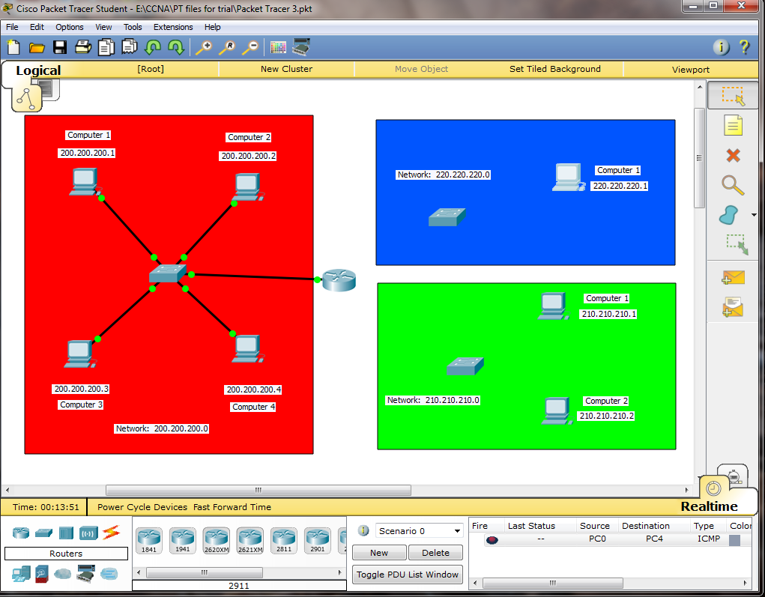1) Double click the packet tracer file “Packet Tracer Router” to start Packet Tracer with the part-made network topology as shown below

2) Complete the wiring for network 200.200.200.0 using Copper Straight-Through cables for all connections. Use router Fastethernet 0/1 interface

3) Complete the wiring for network 210.210.210.0 using Copper Straight-Through cables for all connections. Use router Ethernet 1/0 interface. The topology should now be as below.

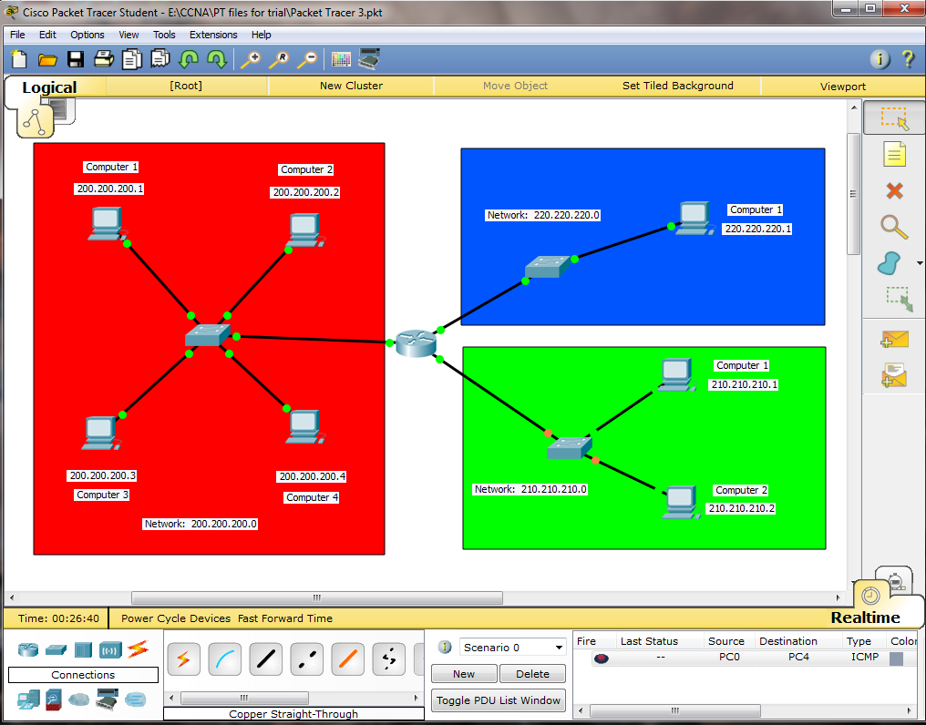

4) Now click on Computer 1 in network 220.220.220.0, then choose the Desktop tab and select IP Configuration and enter the following details closing the window when finished

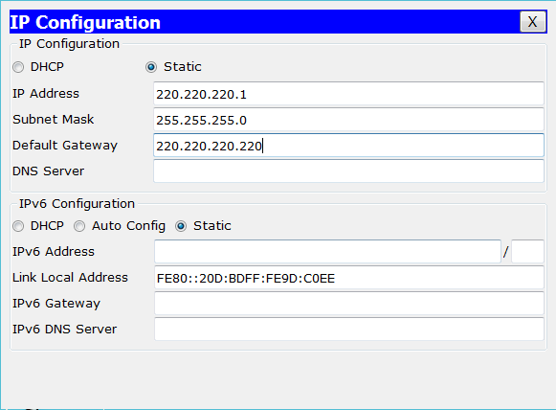

5) Repeat step 4 for the computers in the 210.210.210.0 network and the following details

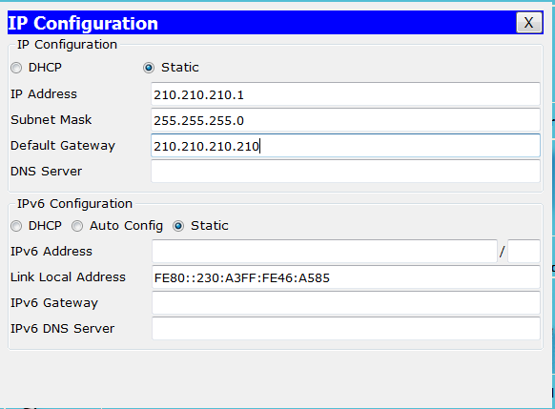

Computer 1

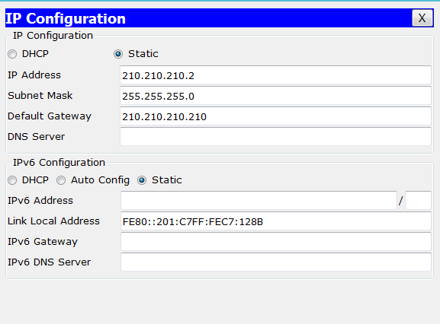

Computer 2

6) Click on the router, choose the Config tab then select Fastethernet 0/1 on the left column and insert the following details for the IP Address and the Subnet Mask

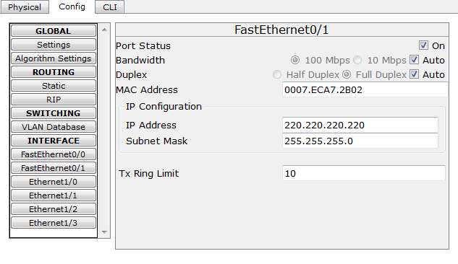

7) Now select the Ethernet 1/0 and fill in the IP Address and the Subnet Mask as follows:

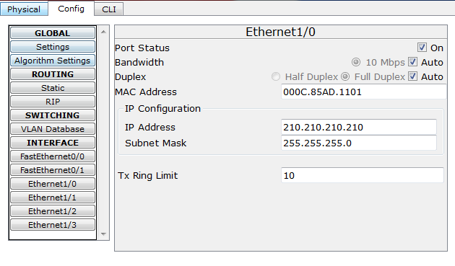

8) Test for connectivity by pinging in Realtime mode.

Network: 200.200.200.0 Computer 1 to all other computers in the various networks

***Challenge***

In Simulation mode and follow the packet journey for the following:

Network: 200.200.200.0 Computer 1 to Network: 210.210.210.0 Computer1

Network: 200.200.200.0 Computer 2 to Network: 220.220.220.0 Computer 1

Network: 210.210.210.0 Computer 2 to Network: 220.220.220.0 Computer 1

What is the purpose of a Default Gateway?

What is the purpose of a Router in networking?